

**UAH Navigation App: Interim Report**

December 5th, 2016

CPE 495 – Senior Design

**Team Members:**

Adam Walters

Jairo Arreola

Komlan Maglo

Daniel Burris

**Project Summary**

The UAH Navigation Application will give users the luxury of having a refinement of the Google Maps API that will lead users to their desired location within the UAH Campus. This concept can be expanded to work with additional buildings that are outside of the UAH Campus. This project is also an opportunity for new students and visitors to get quickly acquainted to the UAH campus map. It would also be helpful for current students or alumni in the case of new buildings or changes to the campus. The Application will allow users to search for their destination by typing in the Class ID, Room Number, or Building ID, and will lead the user to the room. The navigation will be primarily GPS-based. If the GPS loses signal while inside a building, the App will offer an alternative turn-by-turn text-based solution. This Application will focus on development for Android-compatible devices. If the user types in a Class ID, the application will also display information about the class, like the time and day it is offered, information about the instructor pulled from the UAH website, and the Room Number associated with the class.

**Team Description**

*Adam Walters -* Project Lead. Head of Navigation Algorithm. Adam will assume the role of Project Lead. With this role, he will be responsible for managing the due dates that are associated with this project, as well as, ensuring that every member has their fair share of the workload. Adam will also be responsible for researching, designing, and implementing the navigational requirements for this project.

*Jairo Arreola -* Utility Programmer. Jairo will be the Utility Programmer for this project. He will be responsible for creating any sub-programs that the other members will require. For instance, he will be designing and implementing the web scraper program that retrieves class information from a HTML page, the text parsing program that will break down and sort through the web scraped information, and the database insertion program that will take the parsed data and insert it into the database. Jairo will assume the role of Interim Project Lead if a situation should arise.

*Komlan Maglo -* Graphical Interface Designer. Komlan will take on the role of the Graphical Interface Designer. He will be responsible for developing, implementing, and testing the App's Graphical User Interface. Since a well-designed GUI is essential to an App’s success, Komlan will be focusing solely on the GUI.

*Daniel Burris -* Database Manager. Daniel will be the Database Manager for this project. He will be responsible for ensuring information is correctly entered into the database, as well as, creating the program that will grab the data from the database for class information, etcetera. Daniel will also help with the Navigation programming of this project.

**Introduction**

This is a student initiated project. We will be handling the requirements, testing, and costs associated with this project. As such, we had to go out and survey potential consumers of our product to come up with our marketing requirements. Furthermore, we had to research, discuss, and design our engineering requirements.

* Marketing Requirements
* Small Data Consumption

The total application size, in Mbytes, will have to be small to avoid any issues with the user’s memory. Also, the application should only use a small portion of the user’s monthly allotted mobile data, i.e. internet plan.

* Simple User Interface

Potential consumers want the user interface to be as simple as possible while maintaining the full functionality of the application, i.e. few and concise input commands. They don’t want a messy interface with hundreds of possible input commands.

* More Experience/ Faster Result

Users that know what they want to find should have a shortcut that allows them to navigate the interface faster than the standard user. For instance, if the user knows the building and room that they want to go to, they should be able to simply type it into a search bar and get their directions without having to go through two other menus.

* Access to Campus Resources

The application provides users with links to various resources on the UAH website. Such resources include campus map, class and professor information, and general contact information for the various UAH departments.

* Engineering Requirements
* 3-Tap Design.

The 3-Tap Design is a self-named Graphical User Interface approach. In its simplest form, a GUI, which adheres to the 3-Tap Design, would allow its users to get from the start of the application to their desired destination within the application in fewer than three screens, or taps. This design philosophy accounts for eight of eighteen Basic GUI Design Principles. The design principles that it follows are Clarity, Comprehensibility, Consistency, Control, Directness, Predictability, Responsiveness, and Simplicity.

* Database

The SQLite Database will need to be small enough in size to easily fit in the limited memory on the user’s device. The database needs to be capable of holding all of the entries from the UAH Course Listings Website. Finally, the database must be capable of updating itself at the start of every semester.

* Device Capability

The application must work correctly on different Android devices. This means that the user interface has to be capable with various screen sizes. The navigation must be able to work with all of the various types of GPS chips in the devices. The minimum required version of Android should be 4.3.1 (JellyBean) which will cover 97% of all current Android devices, according to Android Studio.

**Background**

Currently, there are no applications on the market that target interior navigation, and more specifically of the UAH Campus. The juggernauts that are Google Maps and Apple Maps are fantastic at handling exterior navigation. Google Maps is currently allowing individuals to upload floor plans to be adapted into 3-D Indoor maps; however, they are prioritizing major airports and hospitals.

The current state of the market involving UAH Apps is very limited. We’ve only been able to find information about two apps, UAH Campus Life and an un-named senior project. UAH Campus Life is an app that focuses on student life around the UAH campus. Its features include information about UAH Orientation, a schedule of campus events, an image of the UAH Campus Map, and links to UAH Orientation’s social media. The other app was an unreleased senior project that allowed users to take a picture of a UAH building, and then the app would give the user some information about the building. According to Dr. Coe, this app was abandoned almost immediately after the completion of CPE 496.

**Trade-off Analysis of Design Alternatives**

* Navigation Alternatives
  + Purely Text-based Navigation

This was an alternative to having an exterior GPS navigation to handle building-to-building travel. In essence, this approach would have been more analogous to the old school MapQuest style of navigation, where the user would print out their directions before leaving and follow the turn-by-turn directions on paper. It would have asked for the user’s location and destination, and then it would output a list of text-based directions to their desired destination. This idea was quickly tossed out because of the lack of control over the starting location, and the fact that it would require more work to implement the exterior navigation as well as the interior navigation.

* + Building Map Pop-Up

This alternative would have asked the user for their destination, then it would have popped up an image that indicated the location of the room within the building. This alternative would have combatted the use of any interior navigation by simply showing the user where the room was. However, this approach was abandoned because simply showing where a room is located isn’t as helpful as telling the user how to get to that location.

* Database Alternatives
  + MySQL Implementation

This was going to be the initial approach to our database. This approach would store our database on a server on a personal Raspberry Pi that would be accessed by the application to pull the required information. However, we decided to scrap this approach because of the server requirements associated with it. One issue was running the server on a personal Raspberry Pi. This could have been done easy; however, we didn’t want to continuously use the RasPi for the server, especially after we graduate from UAH. This lead us to considering paying for a well-known server to host our database on; however, we didn’t want to keep paying the server fees after we left UAH. As a result, we decided to go with another database alternative which will be detailed in the Proposed Approach section.

* + Custom-Made Database Containers

This alternative was one that was mentioned after our presentation. In essence, this approach would do away with needing to use any of predefined database approaches such as SQL, Oracle 12c, Microsoft, etc. With this approach, we would have created our own database containers that we could read and write from. While this approach intrigued us in terms of programming, it was ultimately pushed aside due to the time constraints associated with this project.

**Proposed Approach**

* Navigation Approach

Our approach to the navigation will be to let Google Maps handle the exterior portion, and for us to design the interior navigation. So, Google Maps will lead users to the correct building, and we will lead users to the correct room. To accomplish this task, we will being using the Google Maps’ API, and converting interior buildings into graphs to allow for a multitude of path optimization algorithms to be considered for final implementation. Once the path has been chosen, a list of directions will appear that will lead the user to their desired room.

This approach allows users to skip having to put in a starting location; and, it gives users the information to get to their room instead of simply showing them where it is.

* Database Approach

Our approach to the database will use a SQLite database that will be bundled into the application. The initial download of the app will have a Database that contains all of the course information fields with dummy values implemented into them. Upon the user opening the app the very first time, the app will ‘initialize’ meaning that will take the current time, go and grab the correct course listings for that semester, and then fill the database tables with the correct information. At this point, the user will be free to use the app for directions.

This approach doesn’t require the server overhead that would be associated with a MySQL Database. It will also have a faster execution time of the directions given by the app.

**Response to Feedback**

Instead of writing a huge multi-paragraph essay on the feedback response alone. This will be formatted like a company’s Frequently Asked Questions page. These questions come from the Project Status Review.

“If the app is unable to get the starting location of the person, how will it handle navigation?” - The app will ask for the building that the user is in, as this will be the most common case of not having a GPS signal. If the building that the user wants to go to is the same building that they are in; it will ask them what the nearest exit in the building is. Once it knows approximately where the user is it can direct them toward their desired room. If the destination building is different from the one that they are in, the app will simply get them to exit the building and head to the destination building.

“What about handicap accessible routes?” - To handle this, we would have to have a settings option that would affect the navigational algorithm so that it would favor ramps and elevators above stairs. This will be handled as the first stretch goal option after the initial project has been completed.

“How will you optimize the path? Will you use historical data to help optimize the path?” - Path optimization will be done via a graph optimization algorithm. Buildings will be stored as weighted graphs and the algorithm will choose the smallest weighted path. As far as using user data to help optimization, this is not part of the project for several reasons. First, we would need to have the hardware on the server side that would track and store the user’s route and compare it to previous routes. This would require a lot of back end components and algorithms, as well as driving up the costs of the server. Second, tracking a user’s route could result in a bunch of privacy issues that this group doesn’t want to get involved with.

“Do you plan on changing the logo to adhere to UAH regulations?” - Yes, our logo, that was used in the presentation, was a spur of the moment decision to increase the aesthetics of the presentation. The logo that we will use will fit all of the criteria that UAH has set out. The new logo is shown in Appendix B.

**Impact of Project**

* Environmental Impact

Since this a software project, there isn’t any environmental impacts. Unless, we want to go into the whole discussion on how software is going to destroy the entire human race. But, I would assume that is out of the scope of this project—maybe.

* Security

This project was designed with security in mind. If an attack occurs, the worse that can happen is the manipulation of the app’s features, which in the grand scheme of security is very minimal.

* Inter-Operability

We can’t see any issues with this app interfering with other technologies.

* Privacy

All throughout the design of this project, the user’s privacy has been one of our top priorities. As was mentioned in the Feedback section, we don’t want to data mine our users because we consider that an invasion of their privacy. Furthermore, our app doesn’t require any personal information on the user. It simply needs their GPS location.

* Health and Safety

There aren’t any health and safety issues associated with this project; unless, you want to consider users getting less exercise, because they don’t have to walk around lost in a building, a health issue.

* Regulatory/Legal

None.

* Trade-Offs

This is a navigational app. Therefore, the trade-offs are purely on the software side of things.

**Test Plan**

The overall testing method will be Test-Driven Development meaning that we will write the test before we code the section. We will also be utilizing unit and acceptance testing as we go along. To help test the navigation, we will be using simulation testing. Some of the details for testing are shown below.

* Unit Testing
  + Navigation

These will include testing the graph building, graph path optimization, and navigational information that is associated with this project.

* + Graphical User Interface

These will test that all of the various push buttons, drop downs, links, and images are working the way that they should be.

* + Database

The tests for the database will include but are not limited to:

* + - Insertion Testing

Tests the insertion operations to ensure parsing is inserting correct information into the database tables.

* + - Selection Testing

Tests the selection operations to ensure navigation can pull correct information.

* + - Update Testing

Tests when the database updates itself at the end of a semester, and verifies that the updated information is correct.

* Acceptance Testing

Ensures project is compatible with various devices.

* GPS Simulation Testing

GPS simulation testing will test the navigation algorithm using a plethora of starting and destination locations to test the functionality of the algorithm.

**CPE 496 Course Team-Specific Deliverables**

Adam Walters – Adam is responsible for delivering a working navigation algorithm that will take a starting location and calculate an appropriate path to the destination. Adam will also be responsible for ensuring internal and external project due dates are meet. As Project Lead, he will also be the central line of communication between the project and the outside world.

Jairo Arreloa – Jairo is responsible for creating the webscraping and text parsing programs that will pull UAH course information from the Course Listings Website, and insert them into the database. After completion of this task, he will assist the rest of the team with their responsibilities.

Komlan Maglo – Komlan is responsible for delivering a fully functional (and somewhat aesthetically pleasing) GUI. He is responsible for ensuring that the GUI is capable of adjusting its resolution to fit various devices’ screens.

Daniel Burris – Daniel is responsible for ensuring that the database operates smoothly during every phase of implementation. He will be responsible for implementing, updating, and verifying the database. Daniel will also assist with the navigation implementation when needed.

**CPE 496 Project Schedule**

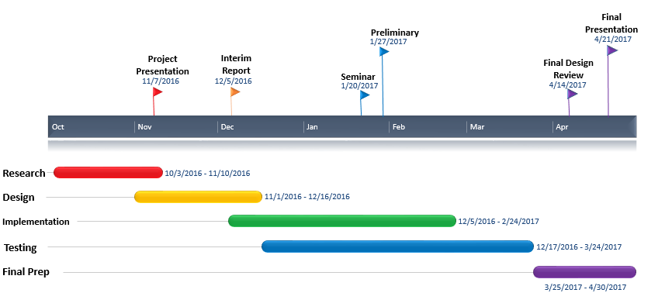

**Professional and Ethical Responsibilities**

I, Adam Walters, vow to uphold the professional and ethical responsibilities laid out by UAH and Engineering Profession Expectations, and to give my best effort for the good of my team and for this project.

I, Komlan Maglo, vow to maintain or support the professional and ethical responsibilities, to do my best for the success of the team and the project.

I, Jairo Arreola, vow to stand by the professional and ethical responsibilities by accomplishing the tasks that my teammates depend from me and providing any help that will be needed.

I, Daniel Burris, vow to fulfill and uphold the professional requirements and ethical responsibilities set forth collectively as a group and personally as an engineer.

**Conclusions**

To conclude our CPE 495 Interim Report, as a group, we didn’t encounter any massive project set-backs, nor did we encounter any issues with our design that weren’t resolved relatively quickly. As a whole, this group has its strengths in its communication, willingness to help, and directness between all of the members. As far as technical strengths go, we are all very adaptive programmers capable of handling many different types of languages.

In terms of weaknesses, none of us have any experience when it comes to app development; as such, we might run into a few roadblocks during our development. However, I believe as a group that we will be able to overcome any such roadblock. Our biggest issue going forward will be time management as a result the busy spring semester that is coming up for us all dealing with school, work, and personal responsibilities.

**Appendix B:**

This is diagram of our behavioral design of the app. This diagram goes through the process of using the app.

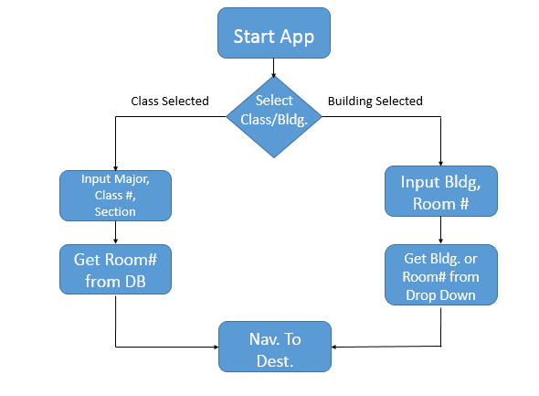

Below is the new logo to coincide with UAH regulations



Shown below is the Database Table Diagram that shows how our database will be organized. It is represented as a UML diagram.

